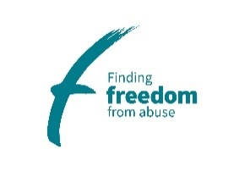 | Finding Freedom  from Abuse

Employment Application

Applicant Information

Personal Details
Preferred Gender: | Preferred Title:
First Name: | Surname:

Address:

Postcode:

Contact Details

Contact Number:

Don’t call on Day/between the hours of:

Email Address:

Right to Work in the UK

Do you require a work permit to work in the UK? | Yes No | Expiry Date:
Do you require a visa to work in the UK? | Yes No
If required, do you hold a valid visa? | Yes No
If yes, please state the type of visa held?
National Insurance Number:

Charity No. 1003275 Application Form v1 May 2023

Please give details of any courses taken or currently being undertaken

Please give details of any other skills or relevant training received

Membership of Professional Organisations and Qualifications relevant to your application

Education

ACADEMIC QUALIFICATIONS

Degrees, A-Levels, GCSEs – where and when gained starting with the most recent | Date | Grade

Previous Employment

Current or Most Recent Employer

Name:
Address:

Dates Employed: | From: | (Enter Date From) | To: | (Enter Date To)
Position(s) Held:
Brief Description of Duties
Notice Period: |  |  | Annual Salary:
Reason for Leaving:

Employer’s Name & Address | Job Title | Reason for Leaving | Dates From | Dates To
If you have any gaps in employment, please give details below:

Demonstration of Your Suitability for the Role
Please briefly indicate why you are applying for this position. You should highlight any particular skills and previous experience you have had that are suitable for this role and provide clear examples of these. When doing so, you should remind yourself of the key knowledge and skills required for the job as detailed in the job description.
Please continue on a separate sheet if necessary.

References

Please provide full contact details of two work related references, one of which must be your current employer, or if not currently employed, your most recent employer. References for shortlisted candidates may be taken up before interview unless you request otherwise. All offers of employment are conditional and subject to references satisfactory to Finding Freedom from Abuse and pre-employment checks, including Enhanced Criminal Records Bureau disclosure where required.

Please do not provide references from friends or relatives. Please note, Finding Freedom from abuse reserves the right to contact any of your past employers.

Name: | Name:
Job Title: | Job Title:
Employer Name & Address: | Employer Name & Address:
Tel No.: | Tel No.:
Email: | Email:
Relationship: | Relationship:
May reference be taken up before interview?  Yes No | May reference be taken up before interview?  Yes No
Information Requested under the Rehabilitation of Offenders Act 1974 (exception) Order 1975
Normally under the above Act, some criminal convictions do not have to be disclosed after a period of time when they become ‘spent’. This does not apply to certain posts that are required to have CRB disclosure.

For posts that require DBS disclosure
Due to the nature of the work for which you are applying. This means that you MUST answer the following questions about current and ALL previous criminal convictions. Any information will be treated with the strictest confidence and will be considered only in relation to this application. Disclosure of a criminal record will not exclude you from the appointment unless Finding Freedom considers that the conviction renders you unsuitable. Failure to disclose this information could lead to your application being rejected, or if you are appointed, to dismissal if it is subsequently learnt that you have a criminal conviction.

- Have you ever been cautioned, or convicted of any criminal offence?  If yes, please give details of the Caution(s) or conviction(s) and date(s): | Yes No
- Have you been charged with any offence, which has not yet been brought to trial?  If yes, please give details of the charge and the date of the hearing (if known): | Yes No
Please tick the box below to confirm your consent to an Enhanced Level Disclosure and Barring Service check and that you understand that failure to reveal information that is directly relevant to the position will lead to the withdrawal of any conditional offer of employment or subsequent dismissal at a later date.

I consent to an Enhanced Level DBS disclosure | Yes

Other Questions
Please give any dates over the coming weeks when you will be unavailable to attend an interview:

_______________________________________________________________

Do you have a current driving licence? Yes No

Do you have use of a car during working hours? Yes No

Please confirm the following:

- I certify to the best of my knowledge and belief, I am not related, or in a relationship with any employee or member of the Management Committee of Finding Freedom from Abuse. (tick if applicable)
- I declare that I am related to, or in a relationship with, the following employee or member of the Management Committee of Finding Freedom from Abuse. (tick if applicable)

Name: ____________________________ Position: _____________________________

Relationship: _______________________

Declaration of conflict of Interest

I declare that there are no potential conflicts of interest (e.g. links with employee’s), or in connection concerning direct contact with Finding Freedom from Abuse if I was offered a contract of employment with Finding Freedom from Abuse.

(tick if applicable)

I declare that there is potential conflict of interest if I was offered a contract of employment with Finding Freedom from Abuse. (Please provide details on a separate piece of paper)

(tick if applicable)

Are you involved with any other organisations in a paid or voluntary capacity?
Yes No
If yes, please give details:

NOTE
If any particulars given by you are found to be false, or if you willfully omit or suppress any information or facts directly relevant to the position, this may lead to the withdrawal of the offer of employment or the subsequent termination of employment. Any canvassing, direct or indirect, for appointments or contracts with Finding Freedom from Abuse is strictly prohibited and will disqualify candidates.

DECLARATION
In accordance with the EU General Data Protection Regulation and Data Protection Act 2018, I give consent for the information contained in this form to be processed in line with Finding Freedom from Abuse recruitment and employment practices. I understand that, if I am appointed, this application form will become part of my personal file and that, if I am not appointed, it will be stored for 12 months from the closing date of the job advert and then destroyed. I have received, read and understood the separate Privacy Statement for Job Applicants.
I declare that to the best of my knowledge and belief the information given is correct. I understand that Finding Freedom from Abuse reserves the right to withdraw the offer of employment or to terminate employment already commenced, if the information given is inaccurate or misleading in any way. Any job offer is conditional upon satisfactory references, a satisfactory DBS check (if specified in the job description) and, if required by Finding Freedom from Abuse, any medical reports.

Name: Signature:

Dated: ____________________________________

Please note that this form can be submitted electronically (without signature) but if you are short-listed and attend an interview, you will be required to bring a signed copy of the application form with you on the day.

Equality and Diversity Monitoring Form

As part of our monitoring processes, we ask for your co-operation in completing the questions on this equality and diversity monitoring form. The information you enter on the form will be used for monitoring only and will not be used in assessing and scoring your application or at the interview stage. We use this information to monitor equality of opportunity and treatment.

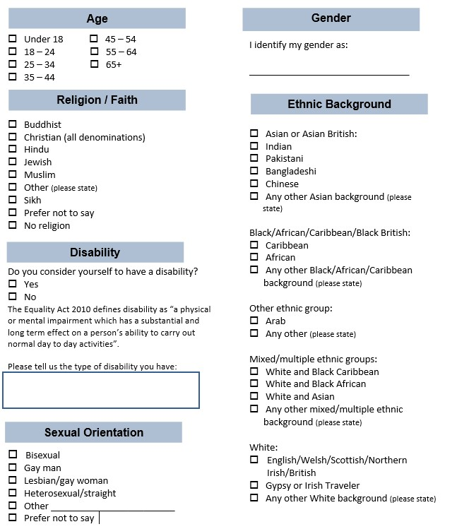

I would prefer not to give this information:

How did you find out about this job:

LinkedIn Website Facebook Word of Mouth Other

Additional page for any further information not able to be added to previous sections.

